Floor Stock Integration Form

Thank you for selecting the Floor Stock Solution. Soon you’ll be able to take the guesswork out of supply management. Our Floor Stock Solution will make replenishing stock for hospital, office, or campus hospitality stations easier and more convenient than ever.

Please fill out the form below in advance of our information gathering call in which you will discuss specific set up requirements, and your various options regarding site settings so we can customize solution options to best meet your needs.

Since product listing is the most vital component of this module, we have listed some information for you to consider, or to be aware of, regarding this.

Is your Floor Stock list(s) with current pricing ready to submit? If not, when will they be complete?

We have developed a worksheet to assist you with defining your requirements for the creation of your Floor Stock module. The worksheet was attached to the email along with this form. Please follow the steps below.

- Complete the Worksheet

Select the display method:
- If items should be listed alphabetically, use the dropdown to select Alphabetically.
- If items should be listed in the same order as listed in the worksheet, use the dropdown to select As Listed.
- Product Name: Enter the name of the item being sold and/or requested.
- Product Title:
  - If the Product will be associated with a Category (i.e. Food, Beverage, Paper, etc.), enter the name of the group under which the product will be categorized.
  - If the Product will not be associated with a Category, enter NA.
- Issuing Unit: Enter the pack size of the unit (i.e. How it will be delivered)
- Count per Issuing Unit: Enter the number of items in the issuing unit.
- Par: Enter the build to level for this item.
  - If a build to level should be displayed for this item, enter the value.
  - If no build to level should be displayed, enter, NA.
- Selling Price: Enter the amount that is charged for this item, in dollars and cents (0.00)
- Add Floor Name:
  - In each column, replace the words “Add Floor Name” with the name of the floor or department (i.e. Oncology, Emergency, 4-3700) to which you will make products available.
  - For each product (row), enter the number one (1) in each “Floor Name” column for which the product should be available. The number will automatically be replaced by a green checkmark.

- Submit the Worksheet

- Submit your completed Excel worksheet via email to mailto:site.launch@catertrax.comalong with your actual menu.

- Please take some time to think about your Floor Stock list format. This can be either master listing(s) of products that anyone can order from, or specific lists for ordering on a unit by unit basis.

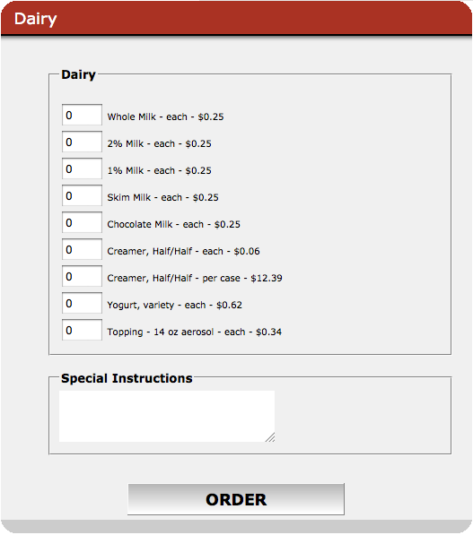 | 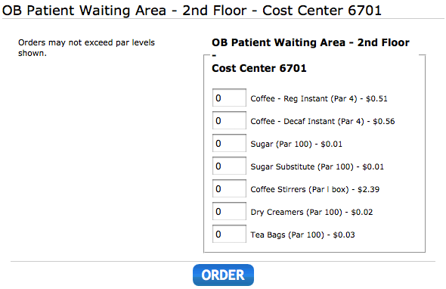

- Please note that we will post your Floor Stock list(s) in the manner and sequence as received by us.
- Menu/Lists must contain:
  - Item names phrased as you wish them to appear
  - Items presented in sequence of desired listing
  - Pricing (no more than 2 decimal places)
  - May contain item par levels (optional, if desired) – See example
  - Par levels will only be relevant if menu is set up per ordering unit and not as a master list.
  - Cost Center or Budget Code numbers to be applied (optional, if desired)

- Answer the Following Questions

- What is your internal terminology for this ordering option (floor stock, requisition, etc.)?

- Will Floor Stock and Catering solutions launch at the same time (if applicable)?

- Who is the primary contact regarding menu questions?

- How frequently will pricing be updated for Floor Stock items?

- Which days of the week are available for order fulfillment?

- Are specific delivery times requested, or will all orders be delivered at your discretion?

- What is your internal terminology for billing method to be applied (cost center, budget code, etc.)?

- Do you wish to receive email notifications when orders are submitted? If so, please provide the email address (es) that orders should be directed to. Please be aware that orders will appear on your site whether you receive email notification, or not.

- Would you like individuals and departments placing orders to receive confirming emails automatically upon order submission?

- Are any orders subject to sales tax? If so, please provide the applicable rate.

- The telephone meeting is intended to allow you and our site specialist to discuss available options, implications of options, and to respond to specific needs or questions that you may have, as well as addressing your expectations regarding timing of the launch and functionality of the module.

- Examples listed below can be addressed during your information gathering call, as well as any other questions you may have:

- Options to be offered for delivery or pick-­‐up
- Lead time requirements for order fulfillment
- Specific information required for billing (Cost Center number, Department Name, etc.)
- Order approval requirements (if applicable)
- Any additional / special requirements for your location

Thank you for taking your time to complete this form. When complete, you may return this to us by email at Site.Launch@CaterTrax.com .

Site Information
Site Name:
CaterTrax Site URL (if known):

Your Name:

